Items for consignment to Grey Doffin
RKG 2022_10_28

GD-26
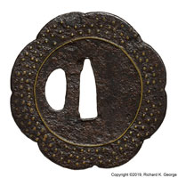
Estimated price: unsure – bot for $500.00
This yatsu mokko gata (8 lobed melon shaped) tsuba measures 68.1mm(H) X 67.8mm(W) X 2.54mm (T, web, max, measured at nakago ana/kozuka hitsu), 3.05mm(T, max). The surface is old - you can see remnants of lacquer, as well as some of that lighter colored material you often see on Ounin and Heianjou zougan tsuba. The surface has been decorated with ten-zougan "dots" as well as circles of zougan which appear to be made up of several pieces of possibly cut material which has been inserted in overlapping pieces to form the circles. I cannot tell whether the kozuka ana is original or not.

As to age, because of the surface, somewhat rustic implementation, etc, I think its pretty old (Muromachi period), but its characteristics don't fit well into the early Ounin "bin" as classically defined - there are only 3 rows of ten zougan dots (and yeah, you can see now the maker "squeezed the outer row here and there to follow the mokkou shape, so I think its original) and the circles do not appear to be cast (though it is interesting that if you look at a lot of their big suemon inlays that are cast, they are pieced together).

EDIT: I changed the description some after getting a chance to study this piece under the microscope more.

Appended are some microphotographs of the surface of this piece. you can see a bit of lacquer here and there, but most of what is on the surface is that lighter colored material you see on a surprising number of Ounin/Heianjou zougan pieces.

GD-27
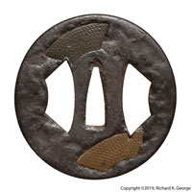
Estimated price:$295? (I’d say more but the yen is so low)

Haynes thought: Bob thinks the fans were added later. He didn’t think Saotome – he thinks its from Kyoto – kyo shoami plate.

Here was my writeup on the piece – I still think it “should” be saotome, but….
Fan (sensu 扇子) themed saotome (早乙) tsuba
This round shaped (maru gata) tsuba is made from iron and measures 83.4mm(H) X 81.4mm(W) X 4.57mm (T, nakago ana, max, mimi), 5.08,, (T, max, to hitsu plug). The surface is worked to look like stone (ishime-ji), and is decorated with several sen (fan) shaped sukashi, which are overlapping and placed to create visual motion in a fashion typical of Saotome work. The piece has had the nakago ana altered at some time in the not too distant past, probably to fit a sword, revealing the layers indicative of the piece being made from a folded iron plate. a few weld lines can be seen here and there in the mimi as well. Two of the hitsu have been plugged, with the plugs either varying significantly in alloy and/or patination.

When I received this piece, I discovered that it had been "brown waxed". This is troublesome because brown waxing is pretty much always used to hide problems with a piece (corrosion issues, patina damage, bad repairs (often that that nasty selenium salt metal stain - the wax is used to give it a more natural color/hide the smell), etc). In this piece's case, the seller had a very reasonable price on the piece as well as providing pretty good images (I could tell something was off from them, unlike so many on fleabay/yahoo!japan where they appear to be deliberately bad, but I digress) so I bought it half assuming something would need to be done to it.

Fortunately, it looks like the primper was trying to hide fairly minor issues, and hadn't done any of the really bad things (like damage the patina scraping loose rust off, patination hacks, etc) that make me cringe when I try and undo the worst of the hacks (or just return the piece - easy to do with reputable dealers in Japan, not so much for a piece off of fleabay).

Because of the hitsu plugs, which are normally both glued with pine-pitch (which dissolves easily in alcohol) and then cut so they fit fairly tightly (well, if its a good one), I spent a while with q-tips and alcohol getting the wax off. I have included a before/after photo. It is interesting that the albedo of the piece changed as well as the color (particularly the "upper" hitsu plugs). Note that this before/after image was shot in identical lighting, so the color differences shown are actual.

In addition, there are a few places on the piece that seem to be covered with what I later found out was probably old camilla/clove oil with fibers from a storage bag/washi fukurin embedded in it - it is mostly on the back, but I'm not sure I'm going to mess with it. I included a couple of microphotographs showing the stuff. [EDIT: see last paragraph – the “stuff” on the surface was actually sukiurushi]
The age is confusing, but I believe it to be from the Momoyama period.
(rambling about sukiurushi deleted)

GD-28
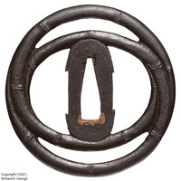

Estimated price:$450?
bent bamboo theme, att. To Sado Island, 78.5mm(H) X 77.5mm(T) X 3.30mm(T, seppa dai), 4.06mm(T, max, mimi), 77.0g Note: Haynes suggested this could be from Satsuma as well.

GD-29
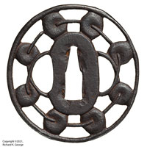
Estimated price: don’t know. Cost $350.01
Probably ko-shouami (Haynes said ko-shouami or shounai (and I don’t believe Shounai). Riceball, head bag, drum, etc theme choose whichever you like the most bones are visible on the mimi

Dimensions:70.7mm(H) X 67.8mm(W) X 3.68mm(T)

GD-30

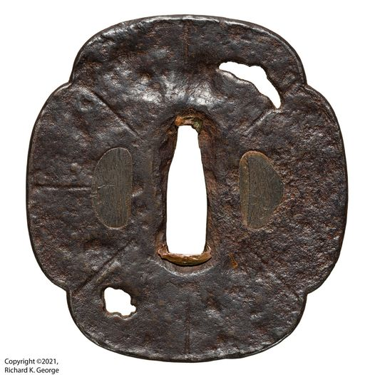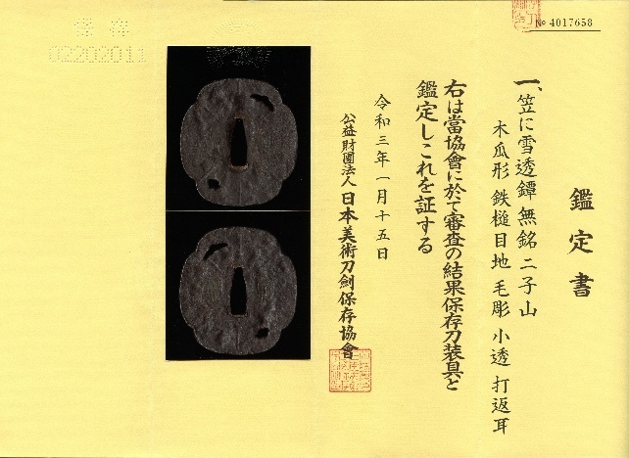
Estimated price: don’t know. Have $496.27 in it – would it even go for that now?
Yamakichibei utushi papered to 二子山 (futagoyama – norisuke location) from sendico (¥51656 + 3420 = $496.27@110.98¥/dollar) NOTE: Haynes thinks its older
dimensions:76.2mm(H) X 70.6mm(W) X 4.45mm(T, seppa area), 5.33mm(T, max), 130.7g

GD-31
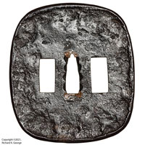
Estimated Price: don’t know – I have $465.62 in it
enpou style tsuba signed Heianjou Nagayoshi (平安城長吉)
This nade kaku gata (or is it naga maru gata?) shaped tsuba is made from iron. It has an Uchikaeshi (upset) mimi and is decorated to look like a stone surface (ishme ji), done with both hammerwork and carving. The piece is a bit of a beast, measuring 87.6mm(H) X 78.2mm(W) X 4.95mm (T, max, mimi), 3.3mm(T, seppa area), and weighing in at 129.9g. It is signed Heianjou Nagayoshi (平安城長吉). it has a pretty heavy coating of wax on it.

The maker is a bit of a head scratcher. A quick check of the "usual suspect" books (Haynes) reveals a few tsuba makers who signed Nagayoshi (長吉), but there was only one from the Kyouto area that would have signed this way, and while the tsuba has some age to it, it definitely wasn't made in in the 1550 to 1600 range that this tsuba maker was thought to work. In addition, that Heianjou nagayoshi did not work in this style (he did brass/other inlay on plate).

While it could be this was an unrecorded maker, it more likely he was a swordsmith. there is a sword maker who signed heianjou nagayoshi that worked in about kanbun. He was noted as being a noted horimono carver so its very possible he did this as the surface looks to have been partially carved.

here's an entry for him:

Nagayoshi (長吉), Kanbun (寛文, 1661-1673), Yamashiro – „Heianjō Nagayoshi“ (平安城長吉), first name „Rokubei“ (六兵衛), he lived
in Kyōto´s Ebisugawa (夷川), he was an excellent horimono carver, the hamon ist mostly a suguha with broad nioiguchi

GD-32
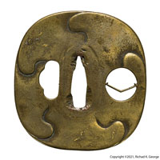
Estimated price: $200? Too much with cleaned front/busted mon?
Brass ko Umetada (mitsutada or juusai?). The piece is made from brass. the theme is a peony which was then inlaid what appear to be hoo birds executed using gold nunome zougan. The piece measures 75.1mm(H) X 70.9mm(W) X 3.56mm(T, max), and weighs 106.7g, attributed to ko umetada.
The piece is made from brass. the theme is a peony which was then inlaid what appear to be hoo birds executed using gold nunome zougan. The piece measures 75.1mm(H) X 70.9mm(W) X 3.56mm(T, max), and weighs 106.7g
From the dodgy auction photos, I thought the piece was some kind of momoyama to early Edo kyo piece.
There are three groups that these soft metal pieces like this tend to get attributed to: (ko-) umetada (or shigenobu, jusai, etc), Mitsutada (group). or ko-shouami. This piece doesn't really look like ko-shouami work (The design is too refined, the nunome crosshatch placement was very precise, etc.). The piece seems to have a lot of age to it (I'd guess momoyama to maybe early Edo), so I believe it would predate the later shouami groups that did soft metal on soft metal inlay (notably awa shouami who did a lot of inlay on brass tsuba early on). I initially thought it might be from the Mitsutada group, but it was pointed out to me that they often had a rougher surface down in the carved areas (that actually looks 'carved'), which leaves ko-umetada.
Unfortunately, when I got it in hand (and as can be seen from the images), the front surface of the piece has been er, aggressively cleaned. They more or less left the back side alone (you can see a little scratching where they started, but maybe thought better of it?). I don't know what the owner was trying to deal with (extreme verdigris, some other problem), but from the fine scratching it looks like he/she used something fairly abrasive (charcoal?). The back is how I'd expect the surface to have looked 🙁 .
From the auction photos, I thought the sukashi was kind of cool looking, but... when you look at it in hand, it appears that it was a diamond mon that is missing the top part.
GD-33
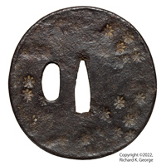
Estimated price: $100?
iron round (maru gata) tenpou. Flower stamp decoration, Edo period (maybe early Edo/Momoyama). Dimensions:78.0mm(H) X 75.4mm(W) X 4.32mm(T, seppa dai), 4.83mm(T, max, mimi), 128.3g

GD-34
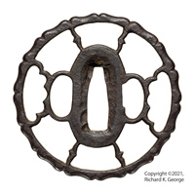
Estimated price: $295-350? Too high?
snow/wild goose (yuki karigane, 雪雁金) theme, probably shouami. I guess maybe you could call it ko-shouami. Momoyama to Early Edo period. 雪雁金透鐔
Dimensions:72.3mm(H) X 72.6mm(W) X 5.59 mm(T), 67.8g
suggested name for mimi description:竹節肉彫耳 - takefushi-nikubori-mimi

GD-35
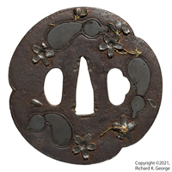
Estimated price:$375? 360?
Mitsu mokko gata. Cherry blossom and gourd(?) motif. Iron body. Flowers/inlays seem to be shibuichi with gold and copper highlights.
Haynes thought it was made by a mito or possibly shounai guy.
Dimensions:81.0mm(H) X 78.7mm(W) X 3.94mm(T,nakago ana), 3.05mm(T, mimi), 6.86mm (T, max), 124.7g

GD-36
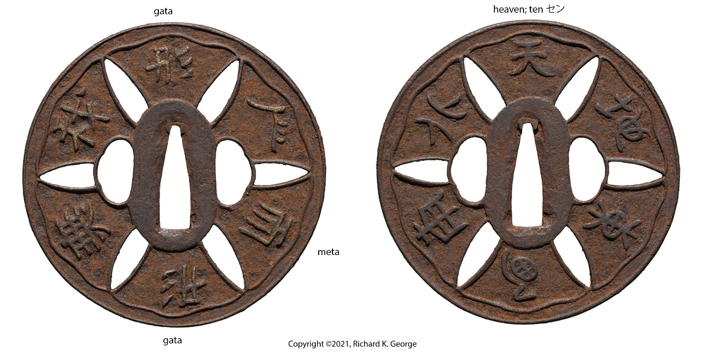
Estimated price: cheap
Attributed to Hizen. Kanji theme (I have only decoded a couple, see notes), iron with gold and remnants of silver nunome. Dimensions:79.9mm(H) X 79,9mm(W) X 3.81mm(T, seppa dai), 4.32mm(T, max, mimi)

